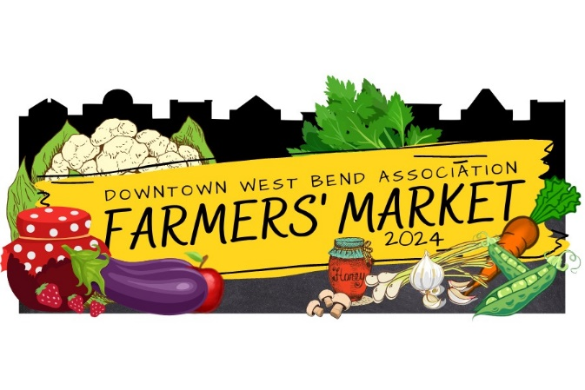

Musical entertainment at the Downtown West Bend Farmers’ Market helps add to the success. Music is enjoyed by all who come and visit the market. During the season we are always complimented on the variety of musical talent we have at the market.

It is time to schedule the entertainment for the 2024 season! It is a great way to get exposure for you or your group and share your talent with a unique audience.

The three locations for music this year:
Location One: Old Settlers Park
This location has a natural elevation above Main Street; bands can set up in front of the gazebo and use the electricity that is available. This is a great location for larger size bands. We will put groups here with four or more members.

Location Two: The Antidote
This location is on the north corner of Cedar Street and Main Street, in front of The Antidote. There is no electricity available here. This area is for individuals or groups of three or less, to play music that does not depend on electricity, microphones etc.

Location Three: West Bend Music Academy
This location is at the south end of the Farmers Market in front of West Bend Music Academy (by the intersection of Main Street and Hickory Street). There is no electricity available here. This area is for individuals or groups of four or less, to play music that does not depend on electricity, microphones etc.

If you are interested or know of someone who is, please sign up!

The Farmers' Market is every Saturday from May 18th through October 26, 2024. The Market is open 7:30am-11:00am. The time scheduled for music is 8:00am – 11:00 am. We expect all groups to remain playing until 11am. Musical groups need to bring their own equipment and necessities. You must have any vehicles moved outside the market by 6:50am so if you need to bring heavy equipment it is suggested that you come early to set up.

We look forward to helping promote local talent! Please note that these opportunities are unpaid, but we encourage you to sell your merchandise or set out a tip jar and promote any upcoming performances you may have. We can be reached by email to answer any questions you may have regarding the Farmers' Market and entertainment. If you have any questions or comments, please email me directly.

Thank you for your time and talent!

Please complete the form and return it by March 8, 2024.
Tomasa Lane
Market Coordinator
120 N Main Street, Ste 120
West Bend, WI 53095
events@downtownwestbend.com
262-338-3909
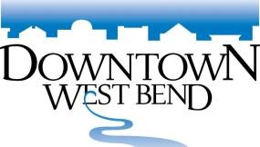
2024 Farmers' Market
Entertainment Reservation Form

Name of Musical Group____________________________________________________________________________

Contact Person_____________________________________________________________________________________

Address_______________________________________________City/Zip______________________________________

Contact Phone____________________ Email___________________________________________________

Where is your group from? __________________________________________________________________________

Type of music_____________________________________ # of members in your band/group _____________

Facebook handle ___________________________________ website _______________________________________

Please check which location your group is requesting to be performed at (Note only Old Settlers Park has electricity).

______ Location One: Old Settlers Park
______ Location Two: North end of market by The Antidote – No electricity
______ Location Three: South end of market by West Bend Music Academy – No electricity

Please check up to 12 dates your group is interested in performing at the Market. (#1 being your most desired date) The number of times your band will play is determined by how many groups are interested in performing and which dates we have available UNLESS you indicate that you only want to play one date.

MAY |  | JUNE |  | JULY |  | AUG |  | SEPT |  | OCT
 | 18 |  | 1 |  | 6 |  | 3 |  | 7 |  | 5
 | 25 |  | 8 |  | 13 |  | 10 |  | 14 |  | 12
 |  |  | 15 |  | 20 |  | 17 |  | 21 |  | 19
 |  |  | 22 |  | 27 |  | 24 |  | 28 |  | 26
 |  |  | 29 |  |  |  | 31

_______ Our group may be available other dates - If you have a cancellation, just give us a call. (If your group can get together on short notice and you might be able to help us out, please check this.)

Please complete this form by March 8, 2024, and send to:

Downtown West Bend Association 120 N. Main Street, Suite 120 West Bend WI 53095
Phone: 262-338-3909 Email: events@downtownwestbend.com

